**WRW2024: 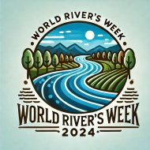 INDIA**

21-27 October 2024

Template for Extended Abstracts

**Title:**

# First A. Author*1, Second B. Author2 and Third C. Author3

1, 2 Author’s Department, Institute, COUNTRY.

(E-mail: [firstauthorsname@aaaa.bbb,](mailto:firstauthorsname@aaaa.bbb) secondauthorsname@aaaa.bbb)

3 Author’s Department, Institute, COUNTRY. (E-mail: [thirdauthorsname@aaaa.bbb](mailto:thirdauthorsname@aaaa.bbb))

***(*) Please, indicate the author making the presentation with an asterisk.***

**WRW2024 Theme:** Theme number [ ]

**ABSTRACT (Headlines: Times New Roman, Bold, 12pt) (not more than 250 words)**

Authors of accepted abstracts will be invited to submit an extended abstract (To be published in proceedings) or full paper (To be published in special issue of Journal/ Edited Book).

Authors are requested to submit an extended abstract not exceeding **THREE** pages (750-1000 words in length, excluding references). Short abstracts of less than TWO pages will not be accepted. The extended abstract should be written in MS Word format, single-spaced, with 12-point Times New Roman font. The extended abstract should include a brief abstract, scope of work and methodology, results, and the main conclusions and recommendations if any.

Incorrect formatting may lead to the rejection of your extended abstract. The scientific committee will select the contributions for oral or poster presentations accordingly.

All pages should be in **PORTRAIT** layout (Margins: top 2.54 cm, bottom 2.54 cm, left 2.54 cm, right 2.54 cm).

Extended abstracts or full papers on relevant topics within the WRW2024 Conference themes are invited for oral and poster presentations.

**Keywords:** Up to 5 keywords, arranged in alphabetical order.

# METHODOLOGY (headlines: Times New Roman, Bold, 12pt) (not more than 300 words)

A brief paragraph on the scope of the study and the methodology used should be included.

Any external source of data usage and figure should be acknowledged.

All tables, images, and figures should be centered.

# RESULTS/FINDINGD (headlines: Times New Roman, Bold, 12pt) (not more than 300 words)

The results, findings and arguments of the work should be explicitly described and illustrated.

***Equations***

Equations should be centered and numbered consecutively, as in Eq. (1).

***Citing References***

References should be cited in the text using square brackets (e.g. [1]) and multiple references separated by comma (e.g. [2,3]). The reference numbers should be numbered in the order that they appear in the text.

***Figures and Tables***

Only **TWO** figures/photographs can be included in the extended abstract. When referring to a figure in the text the form Figure (1), Figure (2) etc. should be followed. The figure should ideally be placed at a point following the paragraph in which it was first mentioned and centred (use the “Figure/Table Caption” style).

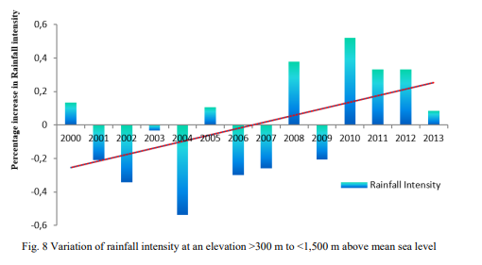

Figure 1. Title of figure (font size 10pt).

Table 1. Title of table (font size 10pt).

|  |  |  |
| --- | --- | --- |
| **Title** | **Title** | **Title** |
| Data | Data | Data |
|  |  |  |

**CONCLUSIONS AND RECOMENDATIONS (headlines: Times New Roman, Bold, 12pt) *(Not more than 150 words)***

A brief paragraph on conclusions and recommendations will make the picture complete and will help the scientific committee to fully understand what is being presented.

**ACKNOWLEDGMENT** : any project sponsorship should be duly acknowledged.

**REFERENCES**

[1] IPCC (2007a) Climate Change 2007: The Physical Science Basis. Contribution of Working Group I to the Fourth Assessment Report of the Intergovernmental Panel on Climate Change (Solomon, S; Qin, D; Manning, M; Chen, Z; Marquis, M; Averyt, KB; Tignor, M; Miller, HL (eds)). Cambridge and New York: Cambridge University Press.

[2] Pratap Singha,, Lars Bengtssonb (2005). Impact of warmer climate on melt and evaporation for the rainfed, snowfed and glacierfed basins in the Himalayan region Journal of Hydrology 300 (2005) 140–154.

[3] International Centre for Integrated Mountain Development (2009). The Changing Himalayas GPO Box 3226, Kathmandu, Khumaltar, Lalitpur, Nepal Tel +977-1-5003222